Plot No: 47 Tabata Industrial Area, Segerea Ward, Ilala District
P.O. Box 71262 Dar es Salaam, Tel: 280 7780, Mobile: 0787 888 855,
www.tusiimeschools.com Email: info@tusiimeschool.com.

TUSIIME
PRIMARY AND SECONDARY SCHOOLS
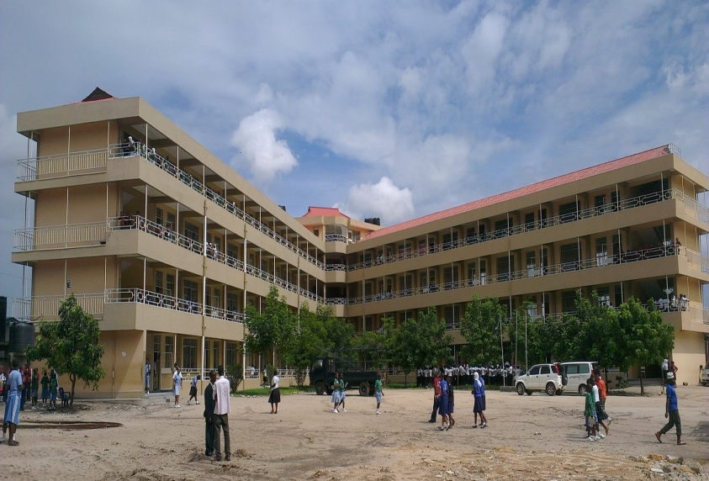

"The Centre of Academic Excellence"
1.0 INTRODUCTION
Tusiime Schools comprise Pre- Primary, Primary and Secondary Schools . The schools are owned by a private company "Tusiime Holdings (T) Limited". It was officially founded in 1999 from private investors and parents’ initiatives. The Schools are located off Mandela road 5 km from the Segerea prison junction and 8km from the city centre. They are on an 8.5 acre piece of land at Plot No. 47 Tabata Industrial Area and Plot No. 827 Block H, Segerea Ward – Ilala District.
Since 1999 Tusiime schools have been gradually expanding and as of now the schools enrolls about 450 Nuresry pupils, 1650 Primary pupils and 1750 secondary students. In terms of staff, Tusiime Holdings (T) Limited employs around 400 teaching, administrative and support staffs.
Tusiime schools are inclusive which offer quality primary and secondary education following our national curriculum. The education provided under the revised competence based curriculum exposes graduate to an international market and challenges.
1. 1 VISION: To be a quality education provider with high academic standards.
1.2 MISSION: To create and disseminate knowledge and develop skills and attitudes that meet labour market and development challenges locally and globally.
1.3 SCHOOL OBJECTIVES :
- To complement government initiatives by providing affordable quality education to young Tanzanians.
- To promote competitive education of pupils/students considering in line with the needs of our country.
- To offer quality education that intends to develop young Tanzanians to became critical, self reflective and who value humanity and respect Nation values.
- To inculcate the culture and strong sense of ambition and determination among young Tanzanians, inspire and equip them with leadership skills and attitude.
1.4 SCHOOL OBJECTIVES AND GOVERNMENT POLICIES
The education provided at Tusiime concurs and is in line with the National Education Policies and/or National Education Act, Tanzania Development Vision (Vision 2025), Tanzania is pursuing through translating it in the MKUKUTA (National Economic growth and poverty eradication/alleviation), The Big Results Now and the Millenium Development Goals (MDG) aimed at elevating Tanzania to middle income countries of the world by eradicating poverty, illiteracy and diseases.
Eventually, Tusiime moulds competitive citizens who will be able to make a better livelihood and be true patriots of our country and uphold our national culture (responsible and accountable).
1.5 WINNING STRATEGY
Tusiime strives to provide education that will produce graduates who will support the social and economic transformation of Tanzanians and the National economy in general. With its vision “To provide the possible highest quality education to children at an affordable cost”; It has remained a school of attainable qualities.
The school program is designed so that all pupils and students have a solid academic foundation and are well-prepared to perform in a demanding higher education environment. It's the excellence performance that promote the school and create competition in acquiring the chances.
In fulfilling the set targets and objectives, the schools’ management team and the Board of Directors are ready:
- To study the market around and determine the magnitude of the competition thus developing winning strategies in order to remain at the top always. What do parents want and expect from us ,is what we offer.

- To cultivate good working relations between the Management and (Human Resource) Staff.
- Improvement of the usage of ICT and state of the art in the course of providing education.
- Ensure supply of teaching and learning materials.
- Create good linkage and cooperation with education stake holders.
- Adapt to participatory leadership approach.

1.6 OUR VALUES
In both our academic and pastoral program, we aim to foster the following.
Belief in oneself:
Integrity, independence, courage, endeavor, reflection and self confidence.
Belief in others:
Trust appreciation, consultation, understanding, generosity of spirit, respect and tolerance.
Commitment to learning:
An enthusiasm for and love of learning
Commitment to the community:
Participation, service responsibility, leadership, initiative, compassion and commitment to equality.
Respect: We respect and value those we work with and the contribution that they make.
Integrity: We act fairly and openly in all we do
Service: We put our clients and customers at the centre of what we do
Excellence: We use our energy, skills and resources to deliver the best sustainable results.
Stewardship: We are passionate about leaving things better than we found them forward looking strategies Implementing the Big Results Now program
To maintain the green colour position in the winning rank increase education research and publication to enhance teachers' competence.

1.7 SCHOOL MANAGEMENT
The school is owned by Tusiime Holdings (T) Limited and managed by the board of directors. The day to day activities are overseen by the Managing Director who is assisted by the Manager under whom three branches of administration demarcate the Nursery, Primary and the Secondary schools. Each is headed by the Head of School, assisted by his/her deputy. Under operational level comes the Academic masters with their assistants. In addition, the Manager’s office has a monitoring department which acts as an internal audit to ensure effective implementation and supervision of teaching and learning processes.
The schools’ management also involves parents through parents’ committee and school board.

2.0 TUSIIME NURSERY AND PRIMARY SCHOOL
2.1 SUBJECT TAUGHT
Pre-primary : The focus is in Reading, Writing in English and Kiswahili, Numbers, Listening Science and Sports and Games

Primary : Maths, English, Kiswahili, Science, Geography, Civics, History, V/Skills, PDS, Computer, French.

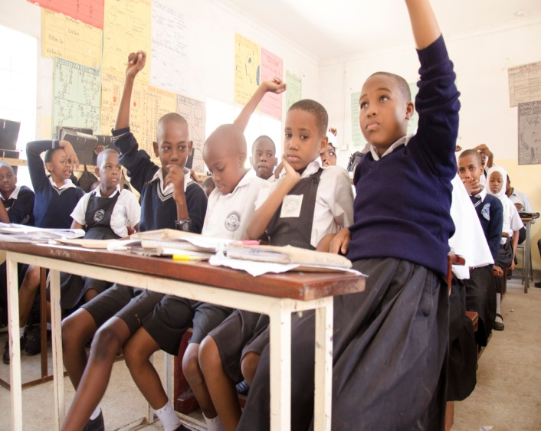
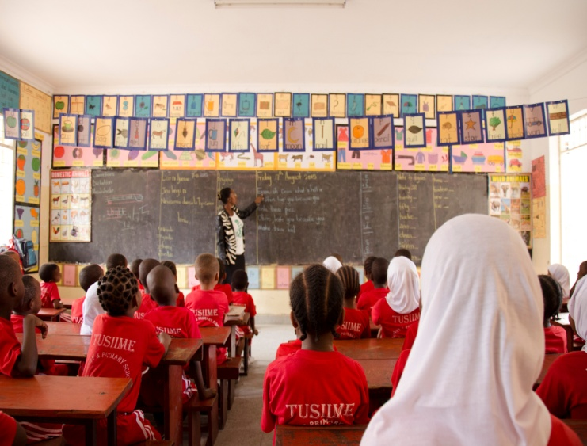

Tusiime pupils in classroom

2.2 SCHOOL CALENDER
There are two major terms for Nursery and primary schools; January to June and July to December. There are two breaks; June and December, with short breaks in March and September.

2.3 ADMISSION SYSTEM AND PROCEDURES
The admission in Primary school is selective while in Nursery is not selective. Admission season starts in October and ends in December; but because of some reasonable and special cases, pupils can be admitted any time of the year.
2.4 ACADEMIC PERFOMANCE
Tusiime Nursery and Primary school has been achieving high academic excellence for more than a decade. The outstanding performance is what draws parents all over the country to bring their children at Tusiime. Below, is a table demonstrating our Primary seven national examaination results from 2008 to date; indicating the school position at district, regional and national levels.

Table 1: Tusiime Primary School Performance for the last Seven Years.
RANKING | YEARS
 | 2008 | 2009 | 2010 | 2011 | 2012 | 2013 | 2014
DISTRICT LEVEL | $\frac{1}{87}$ | 1  87 | 1  88 | 1  91 | 1  129 | 1  99 | 1  101
REGIONAL LEVEL | $$\frac{1}{396}$$ | $$\frac{1}{412}$$ | $$\frac{2}{433}$$ | $$\frac{2}{453}$$ | 1  129 | 1  486 | 1  506
NATIONAL LEVEL | $$\frac{22}{13948}$$ | $$\frac{19}{14388}$$ | $$\frac{39}{14759}$$ | $$\frac{18}{15051}$$ | $$\frac{8}{15051}$$ | $$\frac{2}{15656}$$ | $$\frac{8}{15867}$$

Other remarkable records:
In 2012, over 90 % of the pupils who completed primary seven scored an average of ‘A’ and only one candidate hed ‘B’ . The school also produced the best 10 boys and 7 girls in Tanzania.
The same record was repeated in 2013, with 158 candidates the highest number among the best ten schools in Tanzania, the school was in the second position country wide with the general average score of 230 out of 250 producing the 10 best girls and 10 best boys in Tanzania.
Primary four National examination results for last ten years have been commendable. Our school has always been leading at District and Regional levels.
2.5 EDUCATION OPPOTURNITY
Education Opportunity (EP)
This is an international organization that has registered Tusiime as one of its member. It promotes better education in developing countries through supply of learning and teaching materials of high quality including story books, illustration, laboratory equipment and all other required materials.EP always ensure schools make use of such materials through regular monitoring through pupils tests. Through EP our pupils in Nursery and Primary schools and their teacher have been in position to simplify and consolidate learning and teaching using required teaching and learning resources thus improving the academic performance.

3.0 TUSIIME SECONDARY SCHOOL (TSS)
Tusiime Secondary school which is a comercial bias officially started in 2006 with an aim of enabling our primary school leavers access better and quality secondary education. It was also geared towards increasing access to better secondary education to our children. In 2009, Advance Certificate of Secondary Education was officiated with almost all combinatios. At present TSS enrolls around 1750 students from Form I to form VI. The school follows our national curriculum.
3.1 SUBJECT TAUGHT
Ordinary Certificate of Secondary Education: Basic Maths, Additional Maths, English, English literature, Physics, Chemistry, History, Civics, Kiswahili, French, ICT, Biology, Book Keeping, Commerce.

Advanced Certificate of Secondary Education offers the following combinations:
Science: PCB, PCM, PGM, CBG,
Business: ECA, EGM,
Arts: HGL, HKL, HGE and HGK.

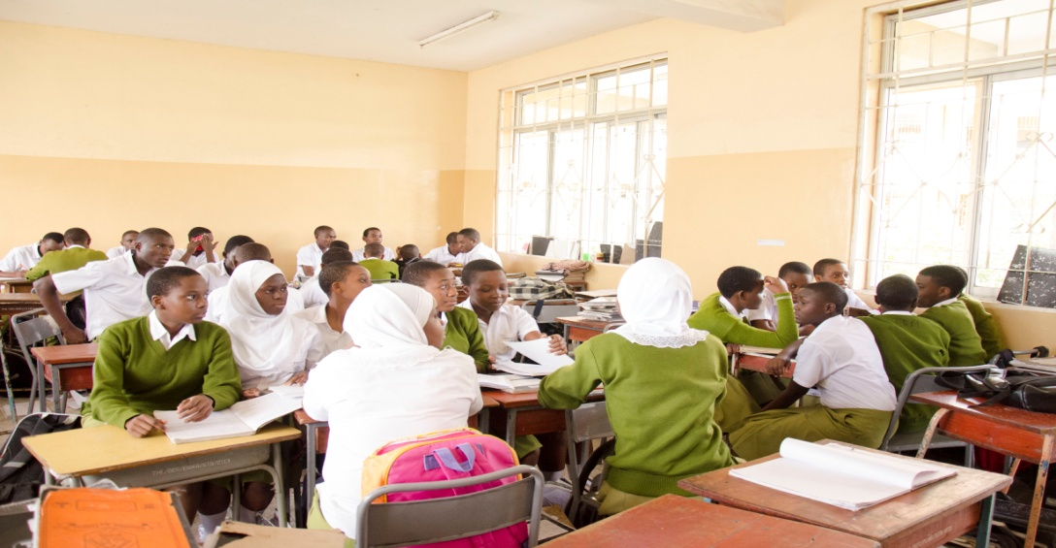

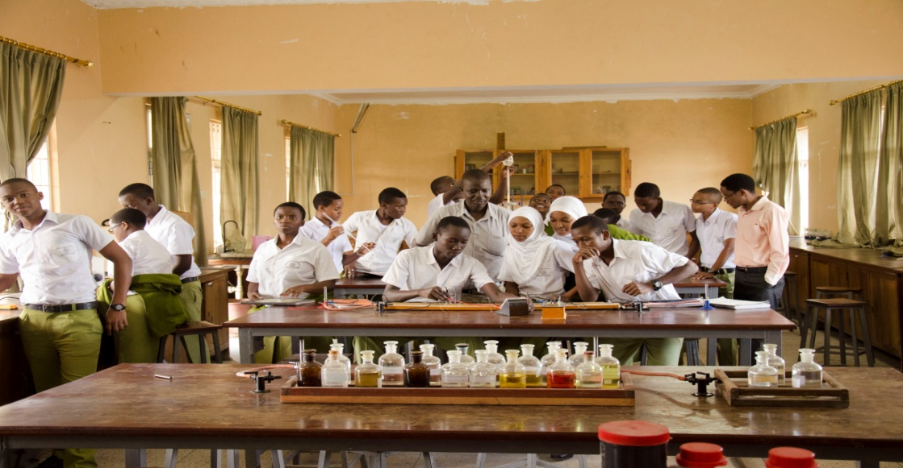

Secondary students in classroom/ Laboratory

3.2 SCHOOL CALENDER
There are two major terms for O' Level -January to June and July to December . There are two breaks; June and December, with short breaks in March and September. For A' Level the school calender starts July to December and January to June. It is also followed by two break and short breaks.
3.3 ADMISSION SYSTEM AND PROCEDURES
The admission in TSS school is selective. For O' Level admission season starts in October and ends in December. For A'Level admission season starts in February and ends in June, but because of some reasonable and special cases, students can be admitted any time of the year in non candidate classes.

3.4 SUPPORT SERVICES FOR OUR LEARNERS
Tusiime Schools offer quality support services for pupils and students to make their life at school better. These include: Medical Services, Transport,(transpoting around 1000 pupils daily), Clean and safe water, balanced diet, enough classrooms with maximum capacity of 40 students each, good dormitories (accomodating around 2300 pupils and students), sports and games, electricity, laboratory, library, computer laboratory and dining hall.
  - ACADEMIC PERFOMANCE
TSS has been perfoming well in all examinations that have been administered at School level, District, Regional and National levels. Below are tables indication TSS academic performance for Form Two, Form Four and Form Six National Examination Results in the last few years.
Table 2: Form Two National Examination Results
YEARS | NUMBER OF STUDENTS | SCHOOL AVERAGE | SCHOOL RANKING
2007 | 24 | 70 - B | $$\frac{11}{363}$$
2008 | 62 | 66 - B | $$\frac{12}{532}$$
2009 | 100 | 61 - B | $$\frac{18}{584}$$
2010 | 181 | 68 - B | $$\frac{10}{294}$$
2011 | 189 | 62 - B | $$\frac{11}{189}$$
2012 | 205 | 68 - B | $$\frac{9}{302}$$
2013 | 204 | 79 - B | $$\frac{12}{304}$$
2014 | 255 | DISTINCTION

Table 3:
Ordinary Certificate of Secondary Education National Examination Results
FORM IV:
RANKING | YEARS
 | 2009 | 2010 | 2011 | 2012 | 2013 | 2014
NUMBER OF CANDIDATES | 76 | 82 | 128 | 164 | 154 | 208
REGIONAL RANKING |  |  |  |  | $$\frac{4}{238}$$ | $$\frac{5}{238}$$
NATIONAL RANKING |  |  |  |  | $$\frac{26}{3256}$$ | $$\frac{41}{3256}$$

Table 4:
Tusiime Advanced Certificate of Secondary Education National Examination Results
FORM VI:

RANKING | YEARS
 | 2011 | 2012 | 2013 | 2014 | 2015
NUMBER OF CANDIDATES | 61 | 190 | 239 | 221 | 389
REGIONAL LEVEL |  |  |  | $$\frac{12}{27}$$ | $$\frac{6}{25}$$
NATIONAL LEVEL |  |  |  | $$\frac{116}{268}$$ | $$\frac{60}{265}$$

NB: In all National examanination results our students have been scoring division one and two for the last three years for Form IV and only division I, II and III for A' Level. Further more our A' Level candidates have all been performing well to join different Colleges and Universities in Tanzania and abroad.

4. 0 PARENTS AND SCHOOL DEVELOPMENT
Parents have played an important role in the development of Tusiime Schools. Their material and moral support has always given us strength to work even harder to ensure that the education we provide to learners meet their expectations. To ensure their active involvement, the following ways are involved.
4. 1 Parents visitation
It does not end just by paying the school fees, but parents are invited to visit their children and assess their progress. It is through this event where parents discuss with teachers about their pupils’/students’ progress.

4.2 Parent School Committee
The school committee is appointed by the parents and it involves parents, teachers, pupils, government education officials and other stake holders.
It's major responsibility is to receive and discuss Primary school progressive report, advise the management on issues that foster the development of Tusiime Schools.
4.3 The school Board for Secondary School.
The school board which has to be approved by the Commissioner of Education comprises of owner of the school, representative from the Regional Commissioner, Head of school, Regional Education Officer, teachers representative and parents.
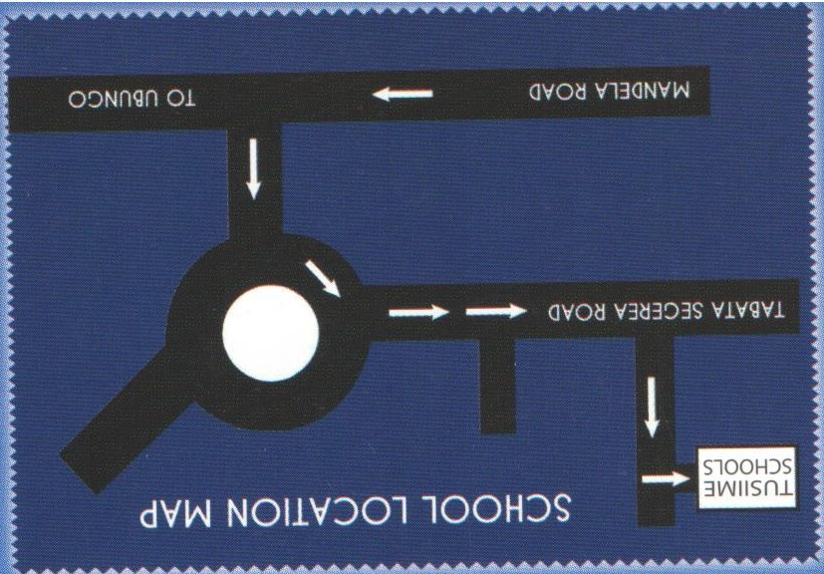
It's responsibility is to receive and discuss Secondary school progressive report. Recommend or/and advise the management on issues that foster the development of Tusiime schools.

Ongoing School Development Projects:
Following government commitment to improve quality of education as advocated in new Education Policy of 2014, the school management has embarked on three projects which are geared towards improving quality of education
- Expansion of school library and laboratories

This project aims at improving the teaching and learning of science subjects within the school and also ensuring the availability and effective use of teaching and learning resources. This will also ensure students acquire required knowledge, skills and attitudes to meet expectations of labour markets
However, this project is not complete and it requires some furniture, books especially for science subjects, laboratory equipments and sound systems.
The pictures bellow illustrate the stage that we have reached in terms of construction:

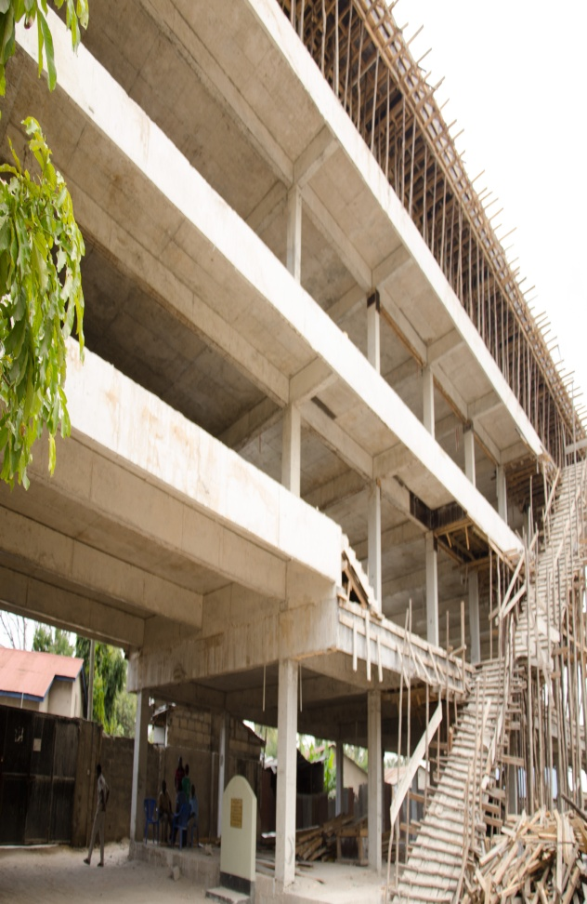
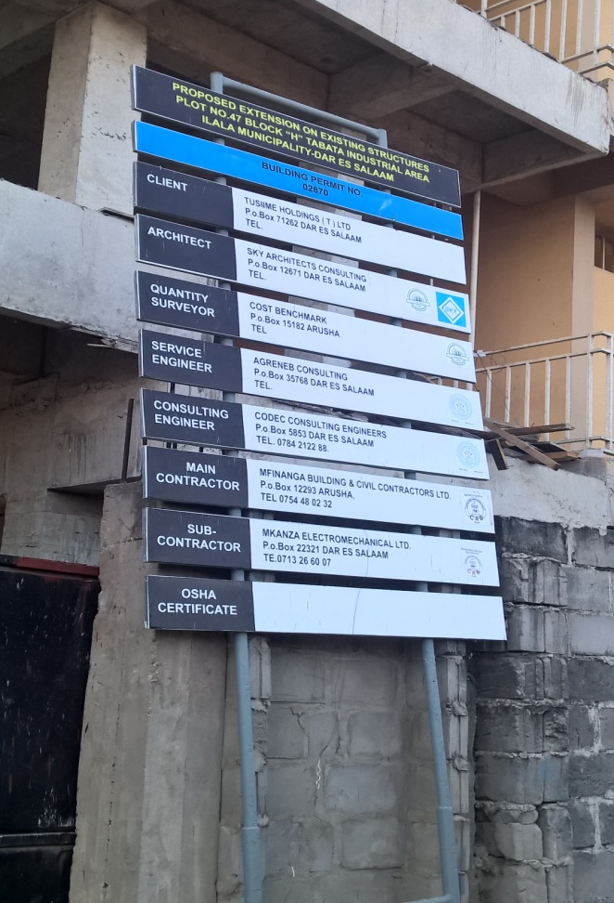

- In service teacher education and development
This min project aims at improving teachers pedagogical competencies in all subjects to meet the requirements of learner centered teaching and learning. The school is conducting in house training, refresher courses in areas of lesson planning, teaching methods and techniques, classroom management, assessment and evaluation. The monitoring department within the school coordinates the implementation of this project. However, the capacity of monitoring department to conduct these in service training is limited in terms of e-learning resources like computers, and over head projectors. Any support in area will be highly appreciated

- English language improvement in the school
This project aims at improving the use of English language as a medium of instruction within our schools and the teaching of English subject in classrooms. The focus is on assisting our teachers to be able to teach well the four language skills; reading, writing, speaking and listening. However, given that English is a third language to most Tanzanians and scarcity of resources and skills, this project requires extra support to make it successful.

